**INSTALLING DNIF**

Before installing DNIF, you’ve got to make sure you’ve done the the following:

* Signed up with us. If not, [sign up with DNIF now](https://dnif.it/signup.html)
* Read the ‘Pre-Requisites’ page. If not, [read prerequisites for DNIF installation here](https://dnif.it/docs/guides/getting-started/prerequisites.html)

You’re now ready to proceed with our **All in One Installation** (A10) to install all the DNIF components (AD, DS and CR) on a single machine.

Here are the steps for a hassle-free installation:

**STEP 1: DOWNLOAD THE CONFIGURATION FILE**

* For seamless installation, with no hassles around typing complex and lengthy commands in the terminal, we’ve brought together all the configuration-related information in this one file. The file will later be edited and executed by you.
* For now, you can simply download and save this [A10 Configuration File](https://dnif.it/artifacts/docker-compose.yml)

**STEP 2: CREATE AN INDIVIDUAL FOLDER FOR CONFIGURATION FILE**

* Create a separate folder at a location of your choice and name it **a10**

***Note*** - *This folder will store the configuration file that needs to be accessed every single time you run DNIF services. Ensure that the folder is easily available and is not deleted.*

**STEP 3: MOVE THE CONFIGURATION FILE**

* Once you’ve downloaded the file, as per Step 1, you will see a file named **docker-compose.yml** in your **Downloads**folder.
* You need to move the downloaded file into folder **a10**, created in Step 2.

**STEP 4: EDIT THE CONFIGURATION FILE**

* Navigate to **a10**
* You’ll now be editing the file **docker-compose.yml** by replacing the highlighted fields with their respective values.
* Fields to be edited are highlighted below:

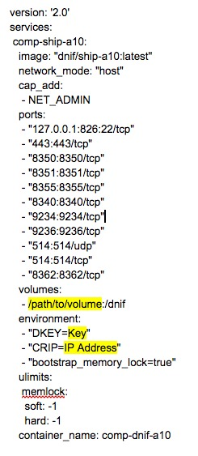

* Replace the highlighted fields with their respective values as follows:
  + **/path/to/volume**: Replace this text with the path where you would like to install the files (for example, /home/test/).
  + **key**: Replace this value with the value/key, mailed to you with the subject “DNIF - Getting Started”. Here’s how:

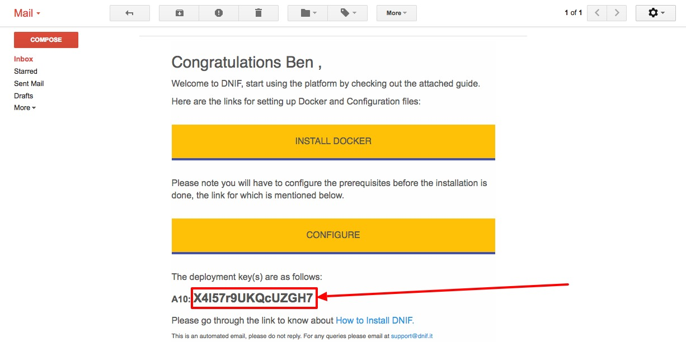

Once you’ve made the above changes, go ahead and save the file. In case you haven’t signed up with us, [Sign Up with DNIF](https://dnif.it/signup.html?plan=freeforever) first.

* + **IP Address**: Replace this value with the IP address of the machine on which the installation is being done.

**STEP 5 : EXECUTING THE CONFIGURATION FILE**

* For the final step, let’s first open the ‘terminal’ window, like below:

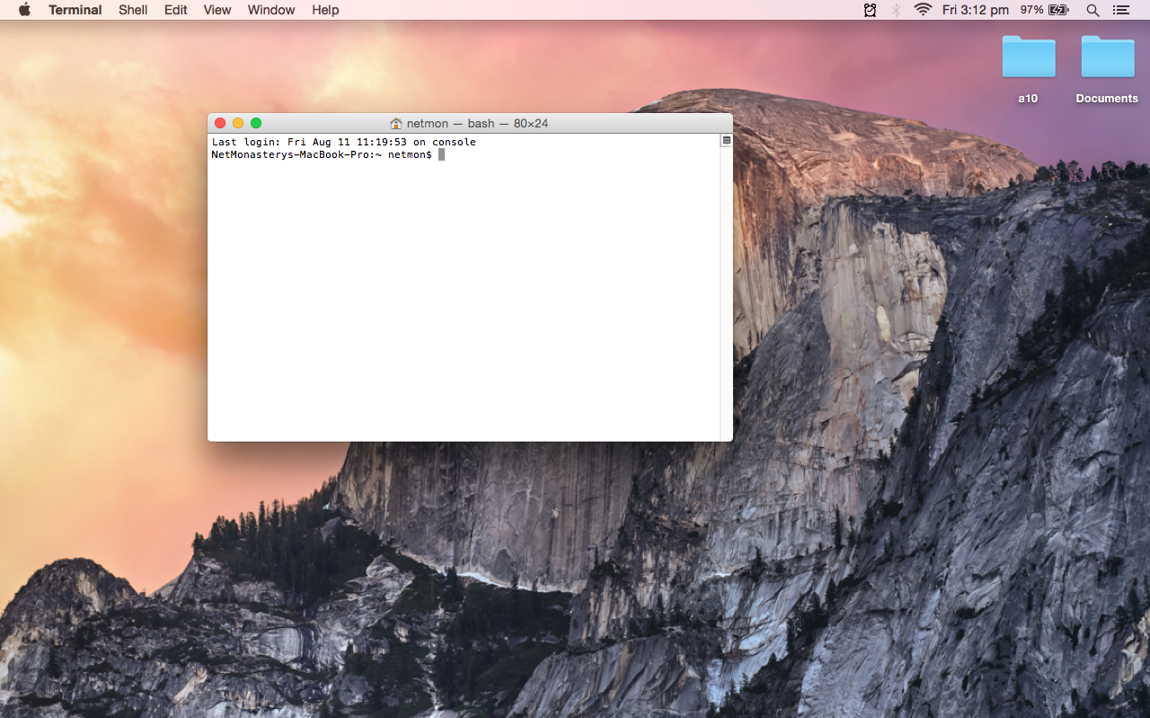

* Now navigate to the path where you have created the **a10** folder for this demo. We have created the folder on the Desktop itself.

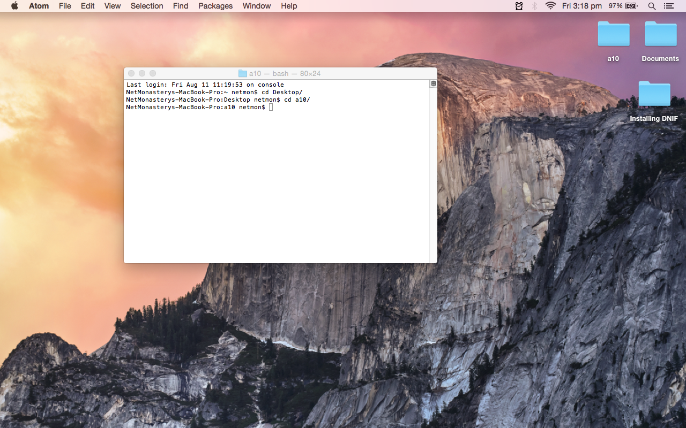

* Install **docker-compose** by executing the command:

$sudo apt-get install python-pip

$sudo pip install docker-compose

* Next, execute the configuration file using the following command:
* $sudo docker-compose up
* The time taken by the above command to fetch the DNIF image from the online repository will depend on the strength of your internet connection. Once the installation is complete, you will see an installation complete message within the terminal or an ASCII art of DNIF.
* The above command successfully performs a “pull” operation , which gets the latest code from the online repository and runs the same.

Do not close the “Terminal” window after the above command has been executed, otherwise the application will cease to operate and terminate itself. However, you can minimize it.

**STEP 6 : MOVING THE LICENSE AND CONFIGURATION FILES**

After successful installation, you may proceed to the next step, which is moving the license and configuration files to a specified path within the installation directory as explained below :

* Open the email with the subject ‘DNIF - Getting Started’.
* Download the files **license** and **signature.bin** attached with this email.
* After downloading the files, move them into the folder **LICENSE**, which you can find within the installation directory, as defined in your **docker-compose.yml**.

In the installation directory, you will find the folder **your_deployment_key**, which is basically the deployment key that you had entered in **Step 4** of the installation. Inside this folder, you’ll find another folder called **LICENSE**, where you have to move the downloaded attachment files.

Once you’ve completed the above step, you’ve successfully installed and configured DNIF.